Objective
At the beginning of each sprint the entire team will have a meeting to plan the next sprint
An overall sprint goal is determined. Items are selected from the product back log to create a sprint backlog. Sprint back log is estimated in hours and compared against hours available during the current sprint

Due Date/Time
This must be completed on the first day of each sprint and turned to the teams AP for review.

Materials
Trello user account (https://trello.com/)
Plus for Trello Google chrome plugin (http://www.plusfortrello.com/)

Procedure

Teams must have already completed the “Product Backlog with Trello” activity before this starting this activity

Step One
Come to a consensus on the goals for the upcoming sprint. Make a list of 4-5 overall goals the team will achieve in the upcoming weeks. Double check the class rubrics to ensure the goals and the class requirements align with each other.

Step Two
Open and log into Trello using the information provided on the team contact sheet. The main Trello page should look something like below.

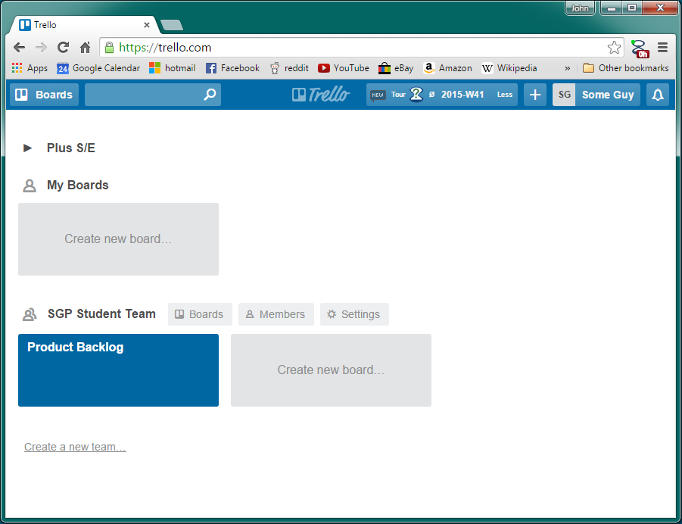

Step Three
Open the Product Backlog board. This board should have previously been populated with all of the lists and userstories for this product. Create a new list that will beused for the sprint planning.

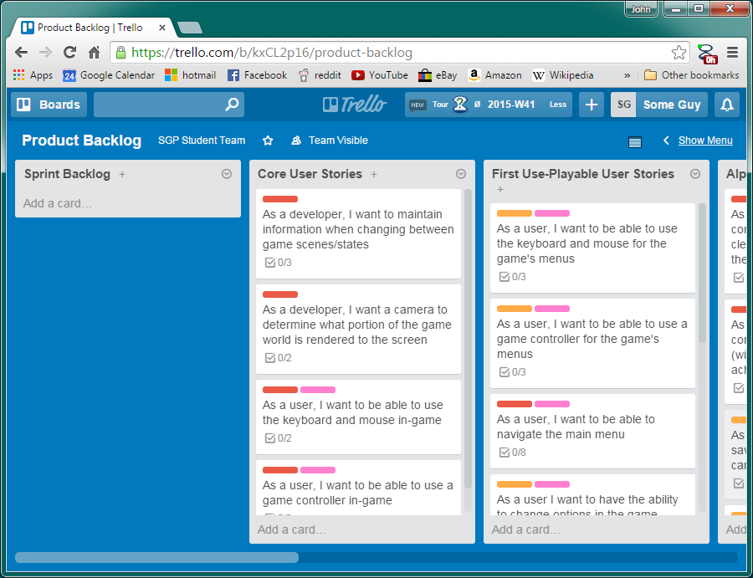

Step Four
Move all userstories from the list labeled for the sprint being planned into the “Sprint Backlog” list. For example if the team is planning for the Core sprint the team should move all userstories from the core sprint list to the sprint backlog list.

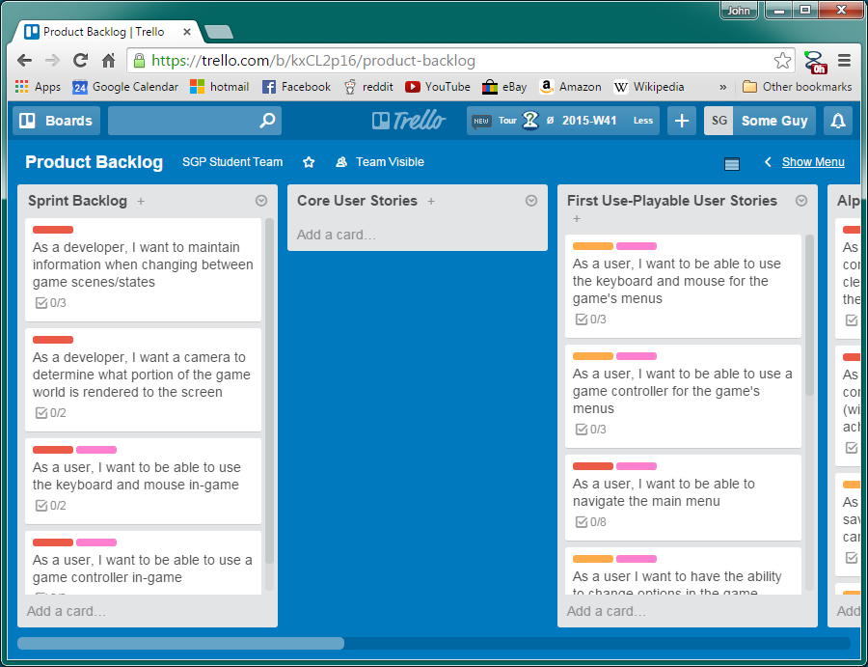

Step Five
With the sprint goals in mind move userstories from all the lists into the sprint backlog necessary to achieve the sprint goals.

Step Six
Go through the planning poker process on all of the user stories that were moved into the sprint backlog list.

Steps to planning poker

Step One (bidding)
The Scrum master reads the userstory and test cases to the team making note of any potential dependencies or complications that they are aware of. The team asks any questions they might have in regard to the story.

Each person evaluates how difficult they think completing the user story and its tasks is without bias from other members. It is important to do this without bias from other team members to ensure that all points of view are represented.

Using planning poker cards each team member will represent that difficulty by how difficult they estimate the task be in comparison to stories from previous sprints and experiences. Each team member will pick which of the possible bids best represents how difficult they evaluate the task to be

Possible bids:

- 0
- 1/2
- 1
- 2
- 3
- 5
- 8
- 13
- 20
- 40
- 100
- Unknown
- Infinite

Special considerations on bids:
- 0 is used when there is no work to be done or an inconsequential amount of work to be done to have the story completed.
- Unknown is used when someone did not have enough information to make their bid. If any team member bids an unknown all of the bids are invalidated and the bids will have to be reevaluated after further explanation.
- Infinite is used when someone has complete understanding of the tasks involved but sees it as an unachievable goal or beyond the scope of a sprint.
- Stories for projects shouldn’t be more than 13.

Step Two (negotiation)
Each team member reveals what bid they decided upon on the previous step at the same time.

The team must come to a consensus on how difficult the task is. If there is a differing of bids the team must discuss why the bids differ and must come to an agreement on the tasks value.

Step Three (Allocation)
After every user story has been bid upon, and have had all their values agreed upon, the user stories must have owners committed to them. The story’s owner will be the person responsible for completing all task related to the story before the end of the sprint.

In Trello with Trello Plus owner are assigned using the hourglass icon. Click the hourglass icon and it will open a new series of fields that deal with tracking hours on a userstory

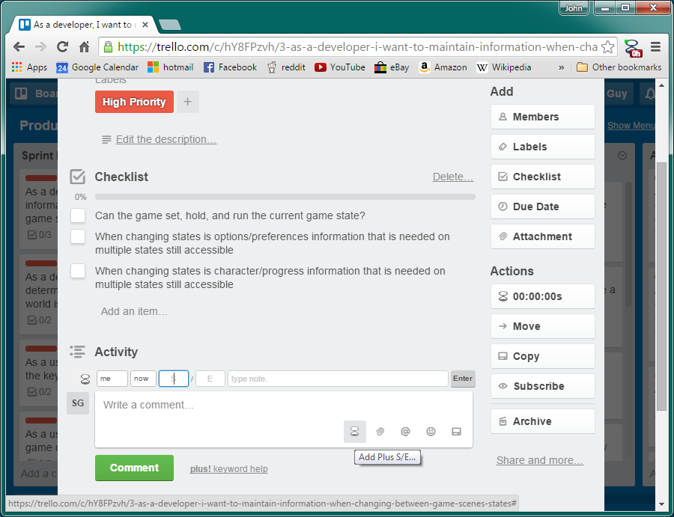

Using the field plus provides set the owner of the userstory in the first dropdown field. This will default to “me” (the person logged in) but it can be assigned to anyone on the team.

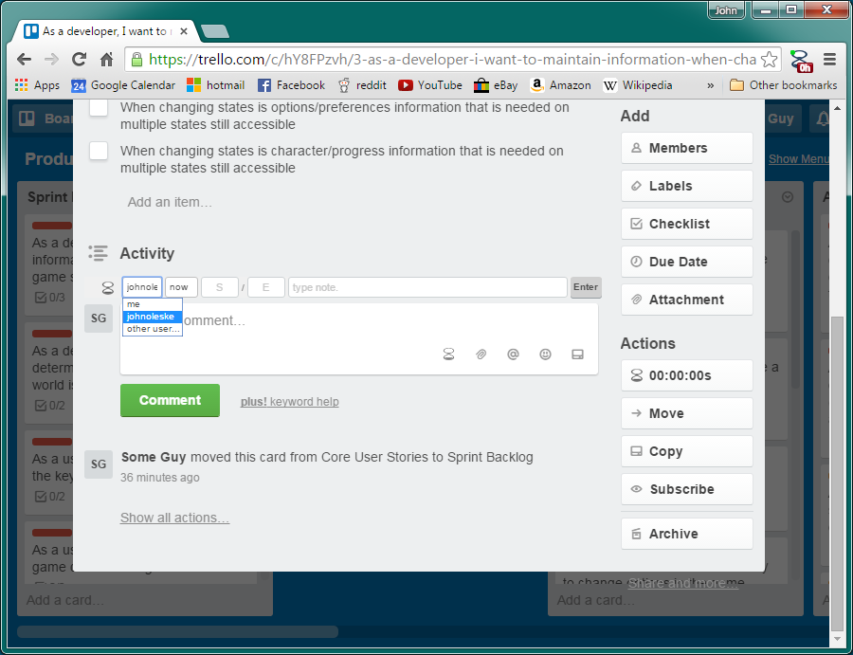

Next in the field that contains an E by defualt enter the teams agreed estimation for the userstory

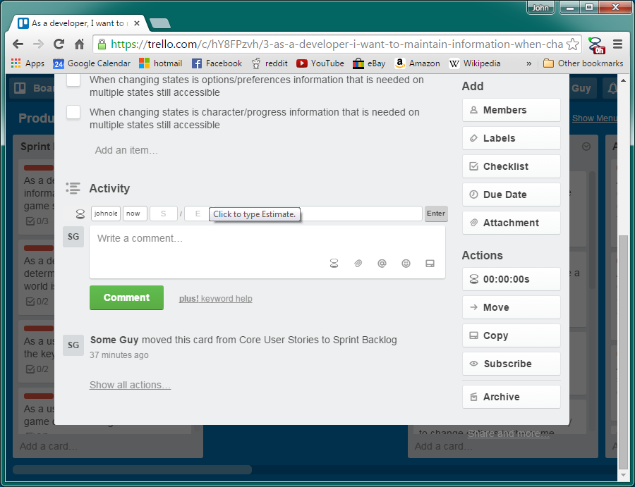

Click enter the enter button and the userstory will have the owner with the entered estimate.

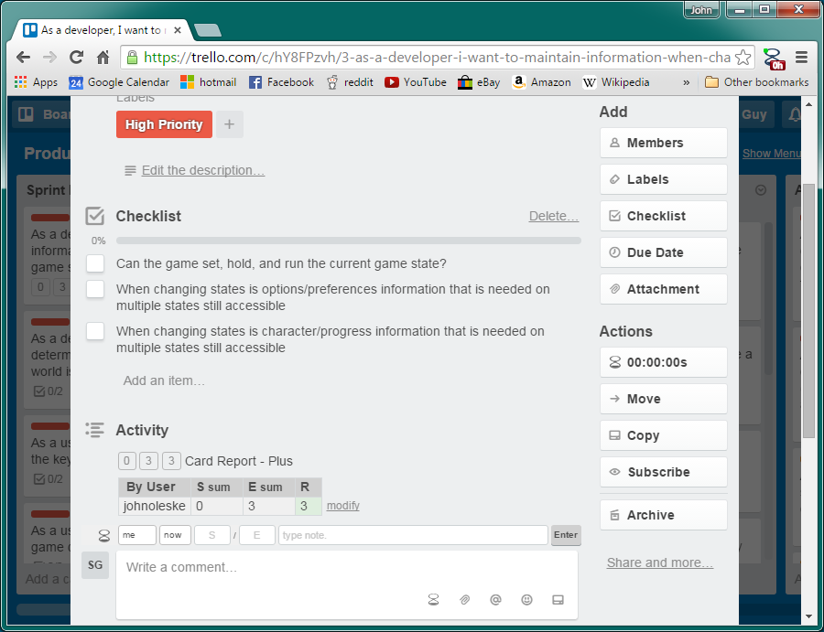

Also be sure to add the owner of the userstory to the member list on the task.

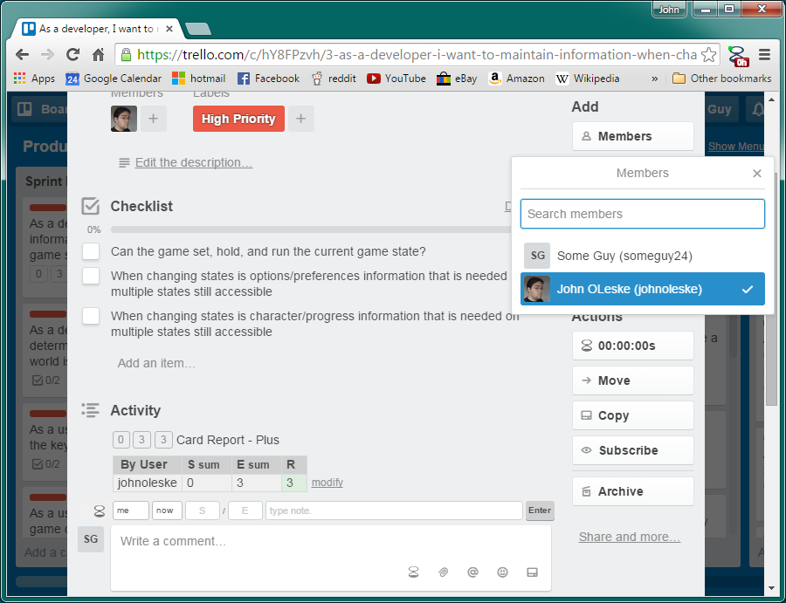

Once all of the tasks have been assigned owners click on the Plus Board Report button. It is the button that looks like a small excel window on the near of the page

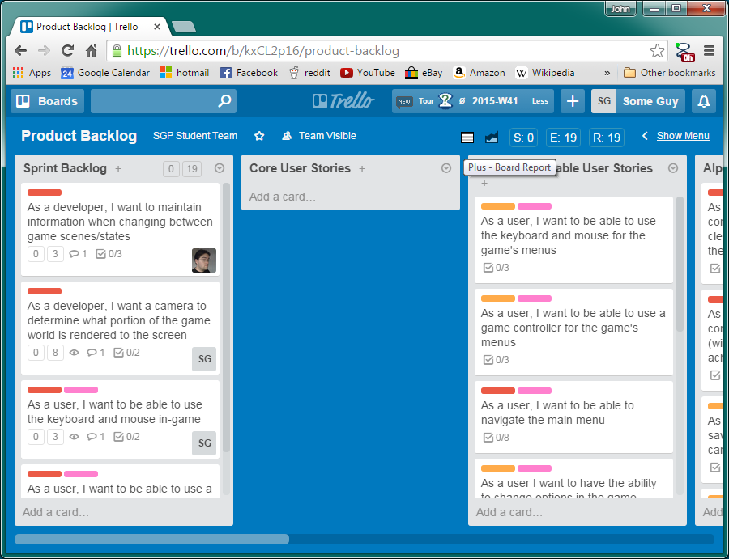

This generates reports based on the status of the board. By default should looks something like below

The dafault report give a lot of information, userstories on the board, what list they are in, who owns the story, what the estimation is…

Compare the over all estimate of the sprint against the planned workload of the sprint. If these differ return to the board and add or remove tasks from the sprint backlog (compleeting planning poker on stories added) untill it matches the planned workload

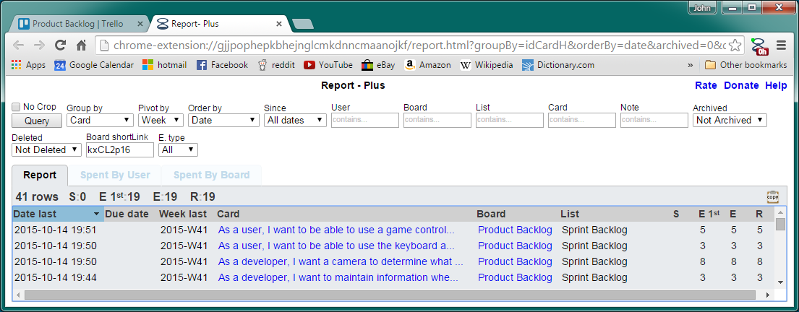

To ensure all team members have equal work associated with them change the “group by” to User and click the Query button. This will then show how much work each member has associated with themselves.

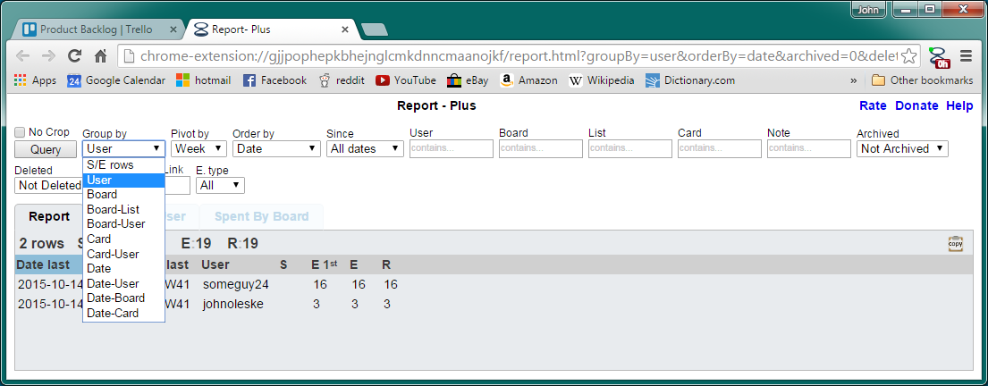

If the numbers are not equal even (like above) go back to the back log and reassign userstories until they are equal

To reassign a userstory open the userstory card and assign the story to the new team member the same way it was done previously is if the story has no owner at all. Enter the owner, enter the estimate, click enter, and change the members to reflect the new owner.

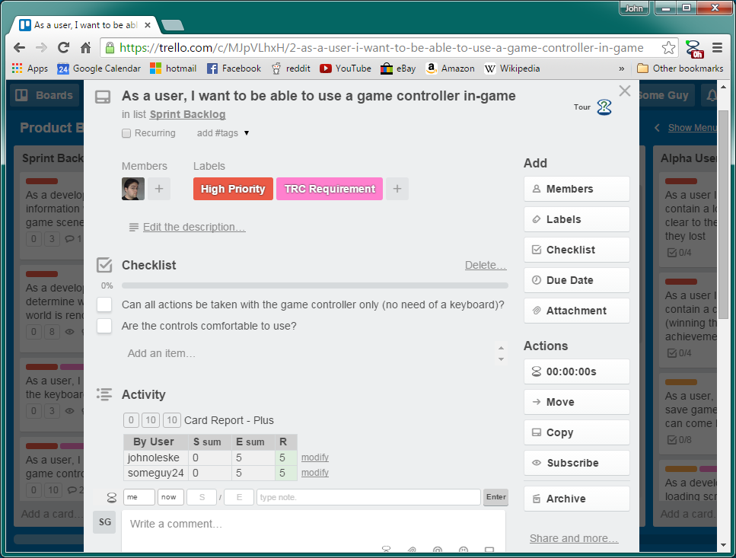

This will add the new owner to the user story but to remove the old owner the comment that contains the previous owner’s estimate must be deleted

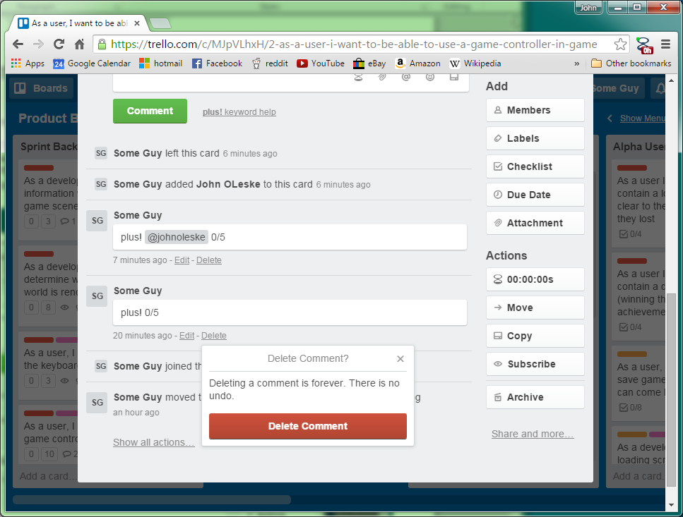

*Important note* The graphs, tables and userstory cards will not show the previous owner being removed until plus is reset. To reset plus click on the hour glass containing a question mark on the top of the page to open plus help.

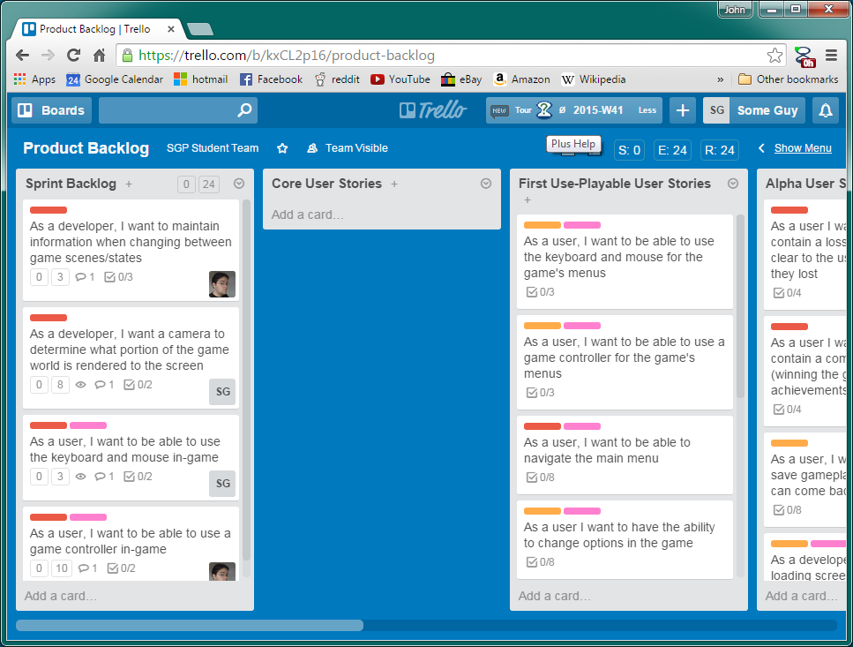

Scroll down to the Utilities (reset etc) section and click the Reset sync button

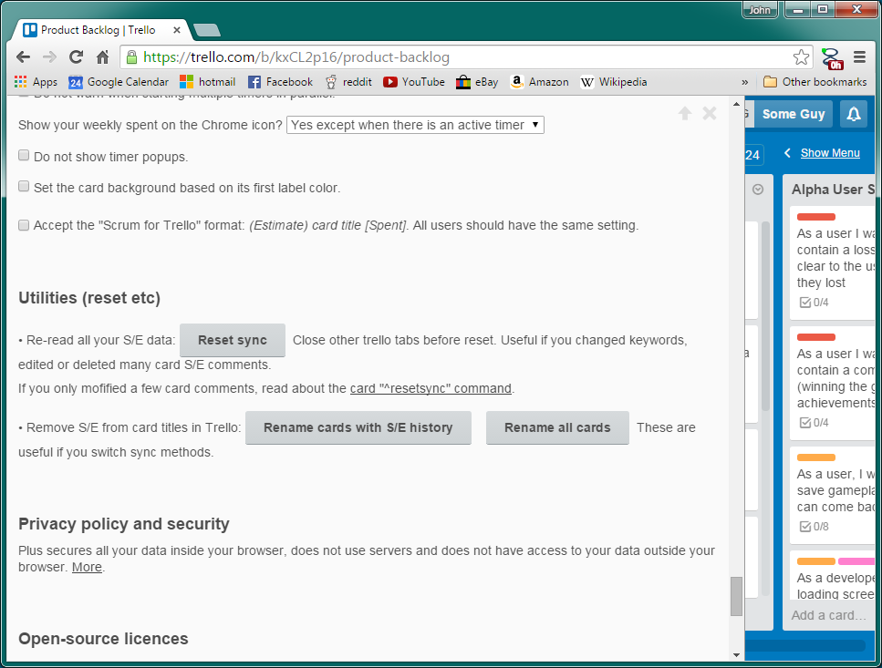

After reset Sync has completed (it takes a few moments) the userstory distribution can be rechecked to confirm a balance on workload among the team

Step Seven
Contact the associate producer informing them that the sprint plan has been completed so they may confirm and accept or deny the sprint plan. Do not continue past this point without getting producer approval on the sprint plan and estimations.

Step Eight
Return to the front Trello page by clicking on the Trello logo on the top of the page. There create a new board for the upcoming sprint.
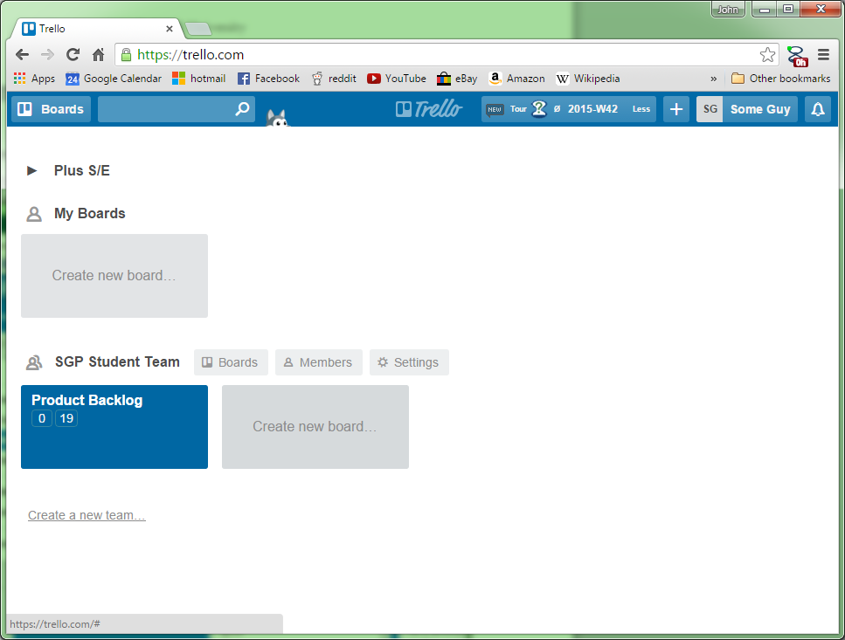

Step Nine
Add all team members (students and staff) to the new board
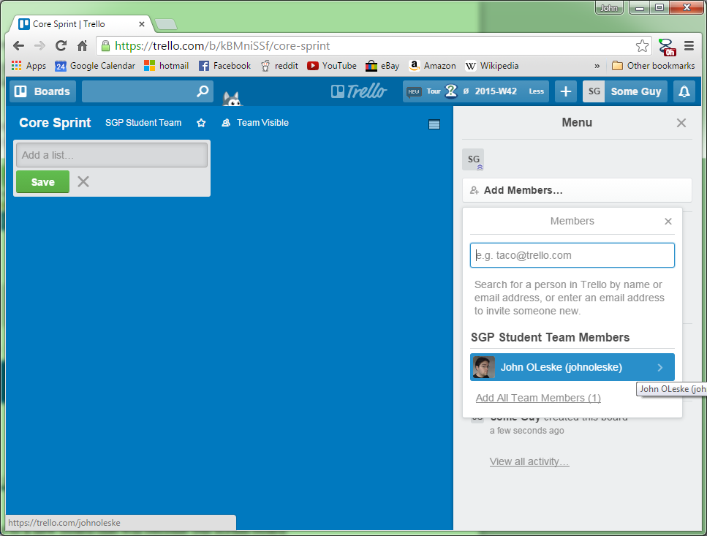
Step Ten
Create lists on the sprint board for all of the statuses of a userstory so we can use it for scrum tracking. All scrum boards should have categories for: On Hold/Dependent, In Progress, To Check (Peer), To Check (Product Owner), and Complete. (The backlog list will be copied over in the next step)
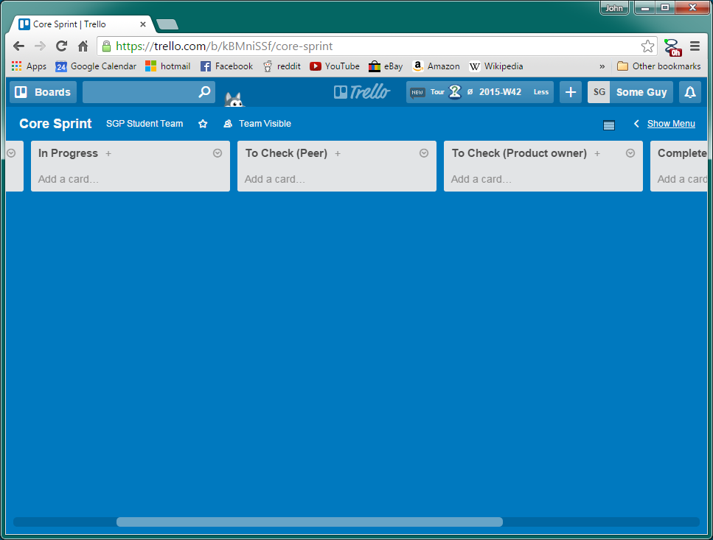

Step Eleven
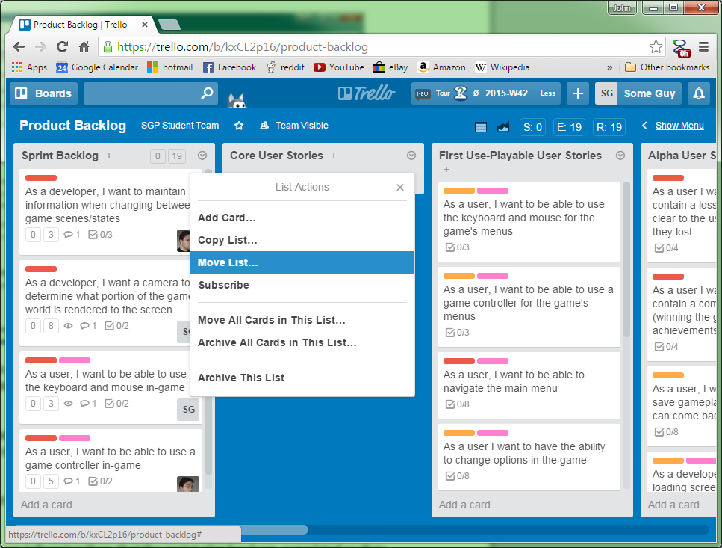
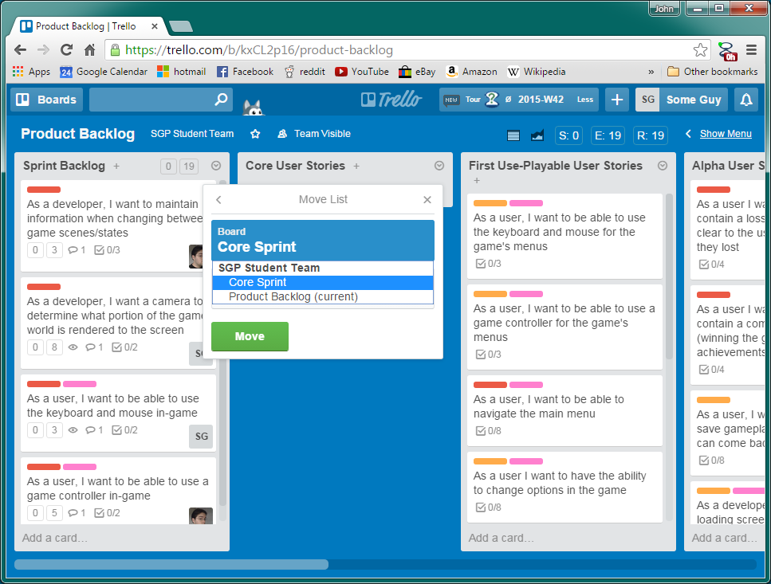
Return to the product backlog board. Move the sprint backlog list to the new sprint tracking board that we just populated.

Step Twelve
Return to the sprint tracking board. Move the sprint backlog list to the front of the sprint tracking board’s lists. Everything should now be set up in order of completion and ready to start the sprint.

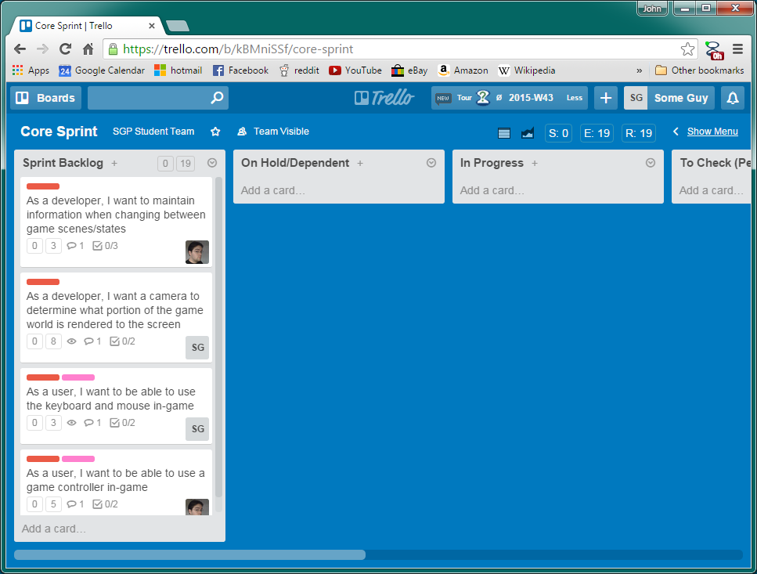

Work submitted:
A final version of the sprint planning must be submitted to the teams AP before the team begins work on the sprint.

